Applying for Grad School for a Research-Focused Degree (M.S. or PhD)
- Before Starting: Is grad school the right choice for you?
A graduate degree can help open doors to exciting careers in science and research. However, grad school is also a lot different from your time as an undergraduate and requires a fair bit of self-reliance and motivation to complete. As such, before beginning the grad school application process, it is important to evaluate if a research-focused degree is the right choice for you and your career goals.

One of the best ways to assess this is to answer the following question: “What is my ideal career?” If you don’t know the answer to that question, but have some ideas, I would strongly encourage you to explore job boards and career websites that can help you refine the answer. Read the job descriptions. Find out what jobs excite you. What jobs you could see yourself doing? Then, look at the preferred qualifications listed in these job advertisements. If a Master of Science or doctorate (PhD) are not listed as the preferred qualifications for the majority of the jobs that interest you, a research-focused degree might not be the right next step for you.

There are also a number of professional degree and certificate programs that might be the right education choice for your desired career. The career centers and professional program advisors here at ISU will have lots of information and advice about these programs. I would encourage you to speak with those folks and learn more if a research-focused degree might not be right for you.

The advice from here on out is intended for pursuing research-focused graduate degrees only. This is the typical timeline for a fall semester start. Note that some programs allow for spring or summer semester start dates, so keep an eye out on ECOLOG for postings at any time of year.

- August – October: Contact, via email, 10-15 potential graduate advisors
For MS and PhD programs in ecology or environmental science, the individual professor is the person to look into, not the program or school. While the location, type of program, cost of living in an area, etc. are all important and a part of the decision-making process, in ecology/ensci, you will only be accepted into a program if an individual professor identifies that they will take you into their lab and have funding. As such, you need to start your grad school search by contacting individual faculty members whose research aligns with your own interests.

When contacting a potential PI, you will write a cover letter that will serve as the body of your email and attach your CV (curriculum vitae). More information on the content of these documents is below.

- October – November: Phone & skype conversations with potential PIs
A fraction of the professors that you contact will respond that they are not looking for new students, a fraction will never respond, and some of them will respond and want to talk further. This is why you need to reach out to at least 10 professors!

The purpose of the phone conversation is to spend time getting to know each other before you pay to apply to a program and the professor pays to bring you out for an interview (and commits to paying for your stipend, tuition, and research for the next 2-6 years!). It is a low(er) stakes way for both the student and the professor to assess if they are the right fit for each other. Think of the phone conversation as an informational interview. It is important to be prepared and professional during the conversation, but the goal is for both parties to share information about themselves and learn about the other person.

The faculty members that are potentially interested in taking you as a student will arrange a phone conversation. During this conversation they will describe their research, the degree program, and potentially the specific project you might be working on. They will also ask you questions about your background, career interests, and why you want to potentially join their lab (you need to have answers to these questions prepared). A list of questions you may be asked and a list of questions you should ask the professor during this phone conversation is included below.

Be sure to send a short, follow up thank you note after the phone conversation!

- December – January: Apply to programs
After or during the phone conversation the professor will indicate whether they think you should apply for their university and program. If you have not received encouragement from a professor to apply to a program, I would strongly discourage you from applying. It will very likely end up being a waste of the application fee as a professor usually has to specifically sponsor your application through the acceptance process at their institution. If they have not indicated that they would consider doing that, don’t apply.

You will likely need three letters of recommendation for your application. These will be the same people that you asked to include as references on your CV earlier in the fall (see CV instructions below). It is important to let these folks know early which schools you will be applying to, which professors, why you are interested in those programs/labs, and the due date. The application will also likely require a personal statement (talk with Grace if you have questions about the personal statement).

- January – March: On-campus interviews & visit weekends
Many programs or individual professors will host prospective graduate students on campus for interviews. Sometimes this is combined with a formal visit weekend where many prospective graduate students are being hosted and interviewed. These interviews go both ways – they are assessing if you’re the right fit for their lab group and program and you are assessing if this is the right lab group, research, program, and town for you.

During these on-campus interviews you will likely meet with the professor one-on-one, the graduate students in the lab group and other’s in the department, and other professors in the department with similar research interests (or they may be members of the department’s admissions committee). If the hosting professor has not provided a schedule prior to your visit, it is okay to request one 2-3 days in advance in order to prepare for the interview.

You will want to have a set of questions prepared for each interaction (it’s okay if the questions are the same for most of the one-on-one interviews with professors!). Additionally, you will hopefully be given time to interact with the professor’s other graduate students away from the professor. At this time, it’s important to ask about the professors mentoring style, if the students feel supported, etc. Try to assess the department culture, what it’s like to live in that town, if the stipend is sufficient to cover living expenses, etc. You need to assess if this is a place you want to be at too!

Finally, it is important to remember that regardless of the setting, you are being interviewed during this entire visit. Don’t over-indulge in alcohol at the social events and use your best manners. Send a thank you note to the professor and your hosts after the event!

- March – April: Offers
Offer letters will go out beginning in late February and into March. You will technically have until April 15th to decide if you will accept the offer. First, when you receive an offer letter, it is important to respond and acknowledge that you received the offer, thank the professor, and let them know the time frame in which you will be making your decision. You need to make your decision in a timely manner, but you shouldn’t be pressured into deciding right away (that’s a red flag!). Remember, if you turn the offer down the professor might have another student that they will make the offer to, but they don’t want to lose out on that student going somewhere else too. Being open in your communication is the best way to be respectful.

The offer will include information on your stipend amount and form (teaching assistant or research assistant), tuition support, and benefits. It is important to review this information carefully and consider if the resources being offered are sufficient for you to be successful. You won’t get rich going to graduate school, but you also shouldn’t have to find another job on the side to make ends meet. See the additional information below about grad student support.

Email Cover Letter: This is the email that you will use to introduce yourself to professors that you are interested in as graduate mentors. The email should be four paragraphs: 1) Introduce yourself and state why you are contacting them, 2) Highlight your background in this field and your career interests, 3) Articulate why their group’s research is interesting to you and aligns with your goals, 4) request to discuss further. An annotated example is below. Really only the 3rd paragraph needs to be tailored for each individual professor.

You can request access to the example cover letters by emailing wilkinso@iastate.edu.

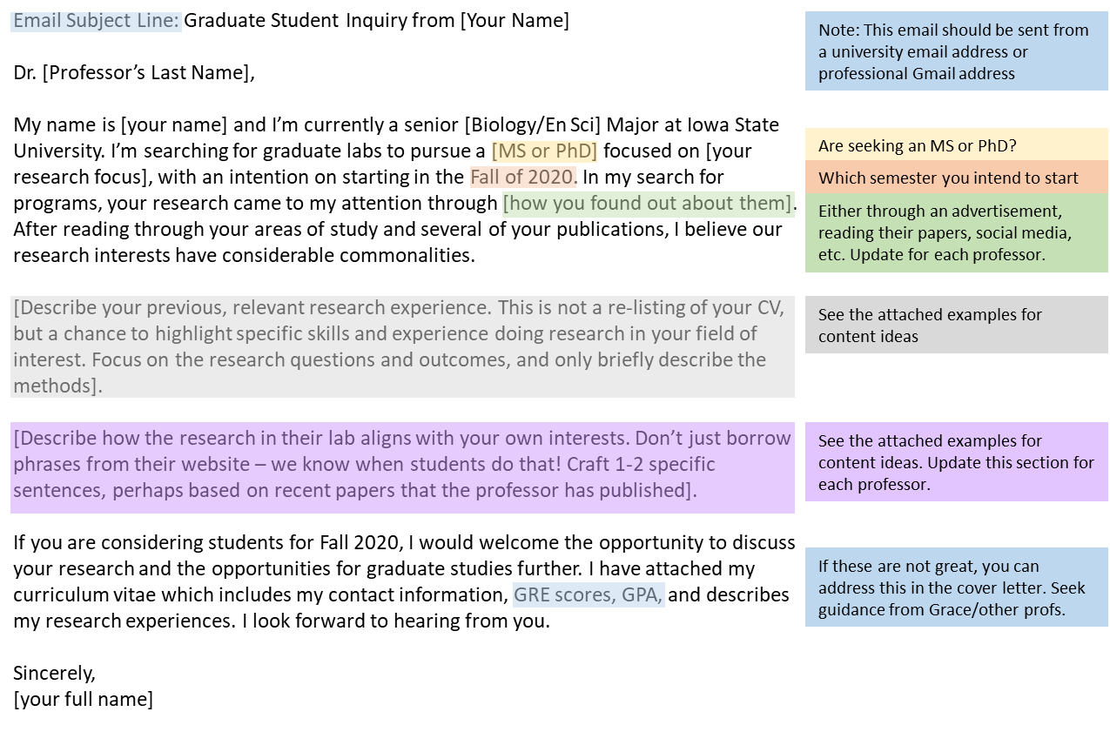
Curriculum Vitae: The CV is an academic version of a resume. While there are some similarities, there are items that you would include on a resume that you would not put on CV for an academic position. As an aspiring graduate student, you should keep your CV to two pages. In general, unless it was a pertinent research or work experience, nothing from prior to undergrad should be on your CV. Additionally, items on your CV should be in reverse chronological order (most recent first, oldest last) in each section.

You can request access to example CVs by emailing wilkinso@iastate.edu.

Recommend Sections for your CV:
- At the top list your name and contact information
- Education (university degree, institution, GPA, date conferred or expected graduation)
- Research Experience
  - Include the title, your role, the supervisor, and dates of research
  - Underneath, include 2-3 bullet points with the research objective, the methods, and the conclusions/outcome
- Research Products
  - Citations for any posters, presentations, or papers from your research experiences
  - Coursework presentations or posters don’t count
- Relevant Work Experience
  - Jobs where you have worked in a research setting, even if it is not related directly to the field you are pursuing
  - Jobs where you gained relevant skills (e.g. life guarding if you are applying to do aquatic field research)
- Research and Other Skills
  - A list of skills that may be useful for research including experience with specific instruments or assays, operating and trailering large boats, SCUBA certification, CPR/First Aid certification, knowledge of programming or statistical languages, foreign languages
  - Do not include proficiency in Word/Excel/Powerpoint. This is no longer a marketable skill
- Relevant Coursework (list any science, math, stats, engineering, etc courses that you have completed at the college level)
- References (see below)

The last section of the CV to be the names and contact information for three letter of recommendation writers/references. Your letter writers cannot be a member of your family or supervisors from unrelated work experiences (e.g. you might have been a great nanny for 4 years, but unless you are looking for a research experience in early childhood development, the parents are not a good reference for grad school!). At least one of your letter writers should be a professor that you have cultivated a relationship with by taking a course, or hopefully done research with in their lab. Ask these people to serve as references for grad school prior to including their name on your CV.

Interview Questions: For the phone and on-campus interview, be prepared to ask the following questions and answer the questions below that. Remember, it doesn’t make a good impression if the professor asks, “What interests you about my lab and research?” and you answer, “Um….”
Questions to Consider Asking:
1. What funding is available for students? Do you provide summer funding for your students?
2. What careers have recent students in your lab gone on to?
2. My career goal is _______. How can you support me as a graduate mentor in achieving that goal?
4. What is your mentorship style?
5. Are there opportunities for students in your lab to attend and present at conferences?
6. Can I speak with other students in the lab about their experiences?
Questions You Should be Prepared to Answer:
1. What research are you interested in and why? (Start broad and narrow to specific topic quickly)
2. Tell me about your previous research experience (make sure to provide the research question, briefly how it was done, and the result)
3. Why do you think you are ready for graduate school? OR Why do you want to go to graduate school? Why a masters (or PhD)?
4. What is your future career goal and how will getting a degree in our program help you fulfill that goal?

Recommended Interview Attire: For interviews in ecology/environmental science you do not need to wear formal business attire (pant suits, jackets, ties, etc). Instead, I would recommend considering clothes that you are comfortable in but look put together such as dark jeans, khakis, dresses or skirts, a sweater or nice top (appropriate for the climate). Nothing with stains or rips. My general rule is “would I be comfortable wearing this to a birthday dinner at a nice restaurant with my grandparents?” If so, that’s probably a good outfit choice!

Graduate Student Support: You should always be receiving a stipend while pursuing a research-focused graduate degree in the sciences. This stipend will come in the form of a teaching assistantship (TA; you will probably be in charge of teaching a couple of sections of an undergraduate lab) or a research assistantship RA; (you are tasked with completing work on a specific grant which is usually also related to your thesis). This stipend is usually per semester for the fall and spring semesters (when school is in session). It is important and up to you to discuss with the professor if they have funds to support you during the summer (usually as a research assistant). TA and RA positions usually come with health care benefits. Talk with students at the university and look on the grad school website at that institution to find out more about the benefits.

For a PhD student, tuition should be fully covered by the professor or department (this is a part of the teaching or research assistantship). Depending on the university, the tuition for an MS student may be partially or fully covered. For example, here at ISU, half of the master’s tuition is covered by the institution and the other half is assessed to the student at the in-state rate. Sometimes this is negotiable, and there are some tuition waiver programs available, particularly for under-represented minority students and first generation college students.

